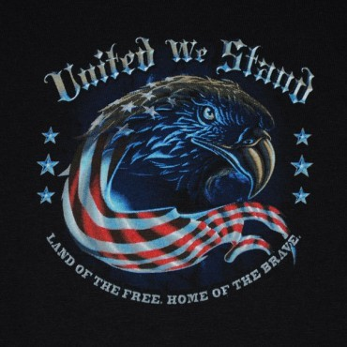
Promote healing amongst all veterans, their families and supporters and to support our military personnel all over the world.

WHAT: Motorcycle event
WHERE: Ontario, CA to Washington, DC
WHEN: May 15th 2019
INFORMATION: rftw.us

Veterans of recent conflicts and those currently on active duty are especially welcome to join us, ride for one or more days or all the way, all veterans and supporters are welcome.

